TERRAFORM -01
1). Install Terraform on your PC
Terraform Installation : https://developer.hashicorp.com/terraform/install
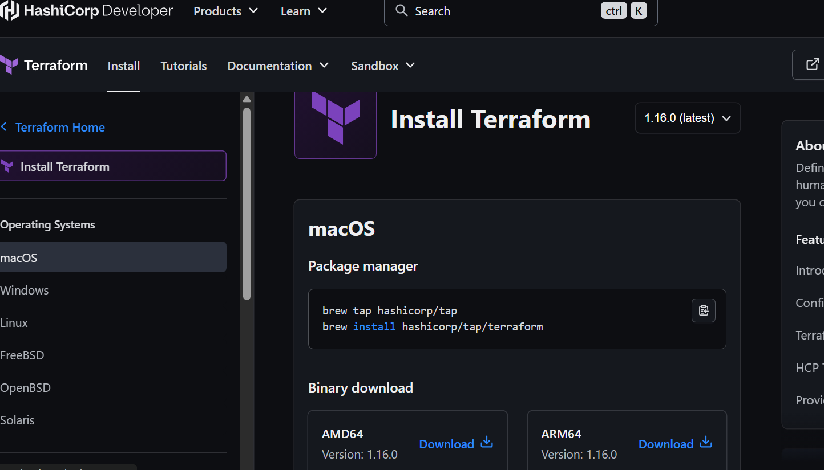
1. Download Terraform → Windows AMD64
2. Extract terraform.exe to: C:\Terraform
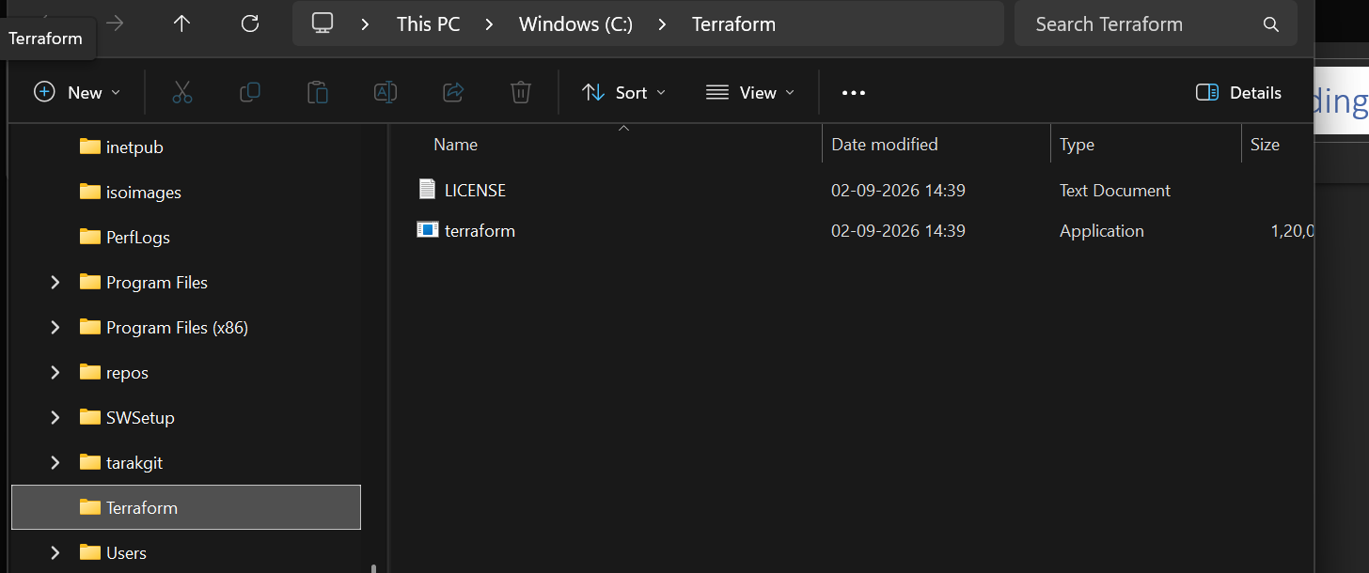
3. Open Environment Variables
Search → Environment Variables
System Properties → Environment Variables
4. Under System variables → Path → Edit → New,
add: C:\Terraform
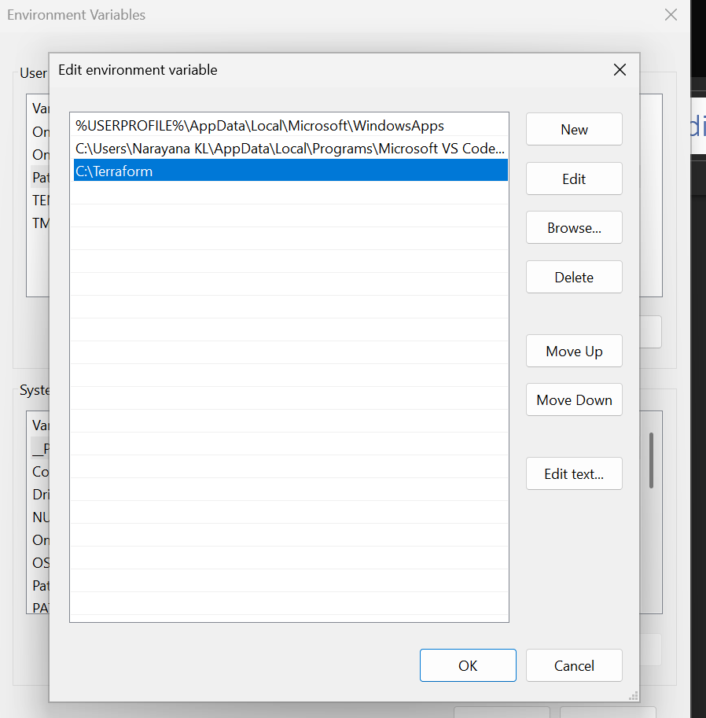
5. Click OK → OK → OK
6. Close and reopen gitbash/powershell/vscode
7. Verify: terraform –version
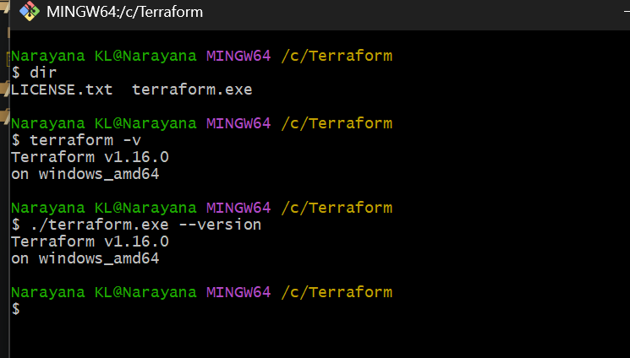
2). Execute all the templates shown in video.
Terraform Template Execution in VS Code
1. Create a folder
C:\Desktop\Terraform-lab
2. Open the folder in VS Code
· VS Code → File → Open Folder
· Select Terraform-lab
3. Create main.tf
Paste:
resource "local_file" "tarak" {
filename = "tarak.txt"
content = "Hello, World!"
}
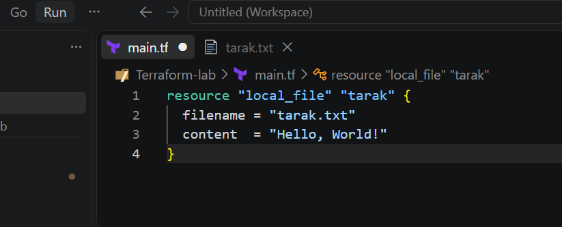
4. Open VS Code Terminal
Go to: Terminal → New Terminal
Make sure you are in:
PS /c/Desktop/Terraform-lab
5. Initialize
terraform init
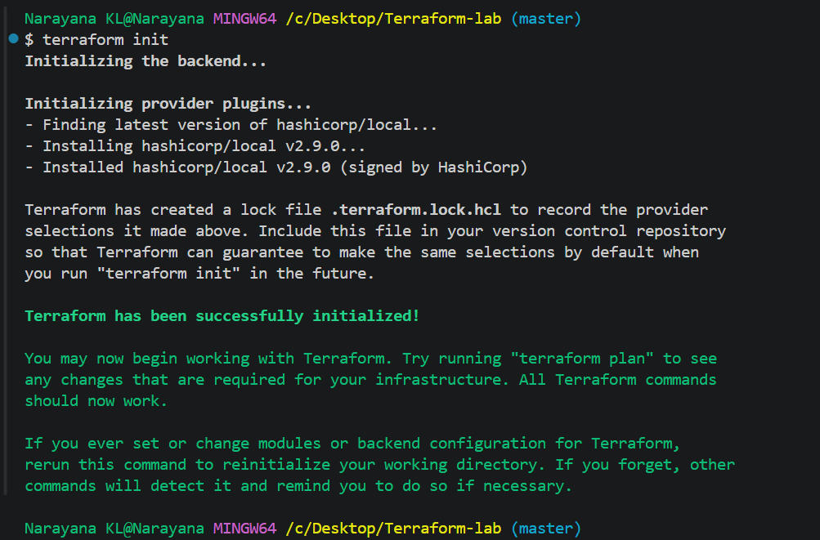
6. Check the plan
terraform plan
7. Execute
terraform apply
Enter: yes
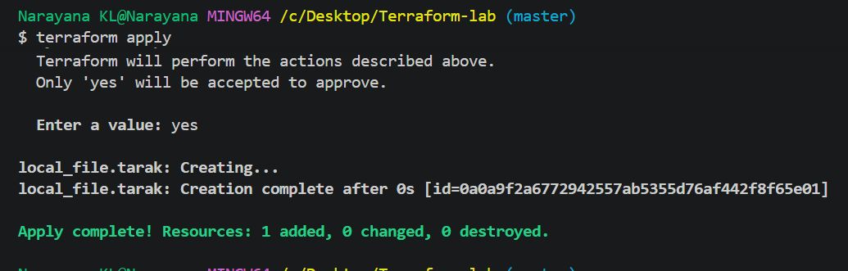
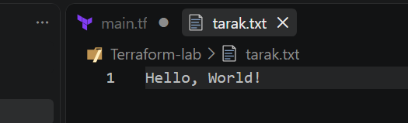

2.1First Template is main.tf using local provider
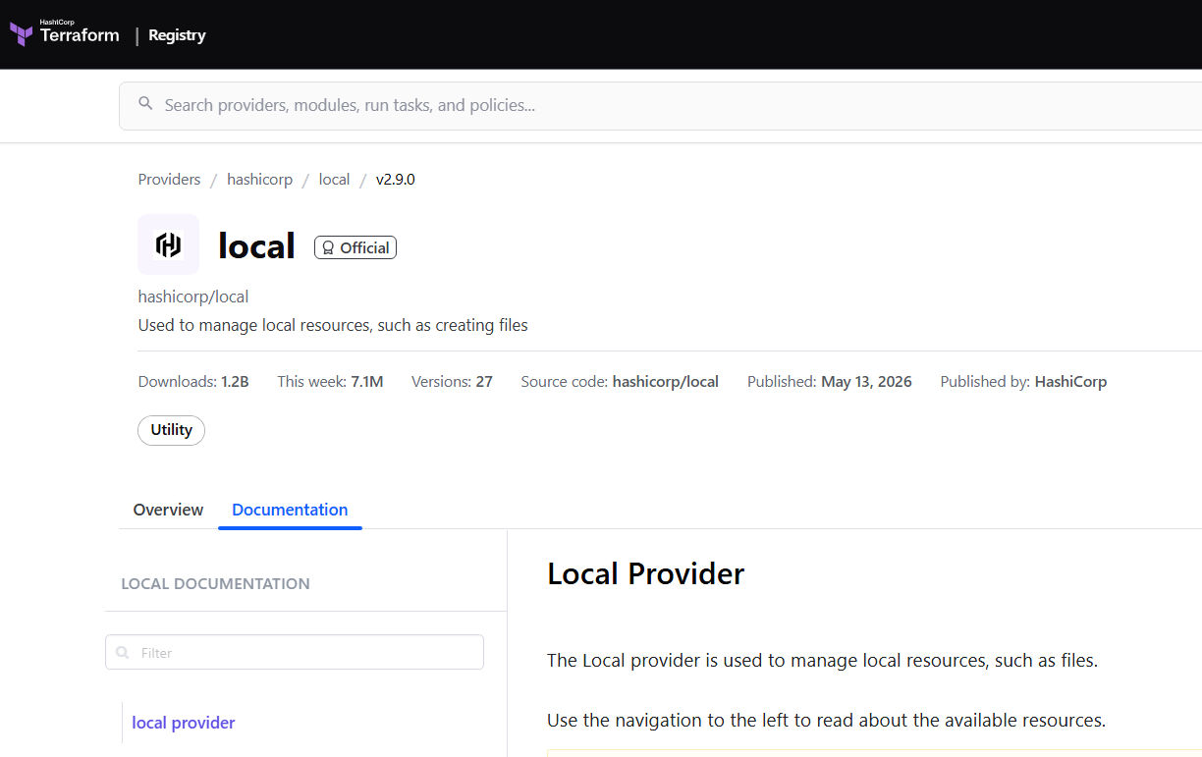
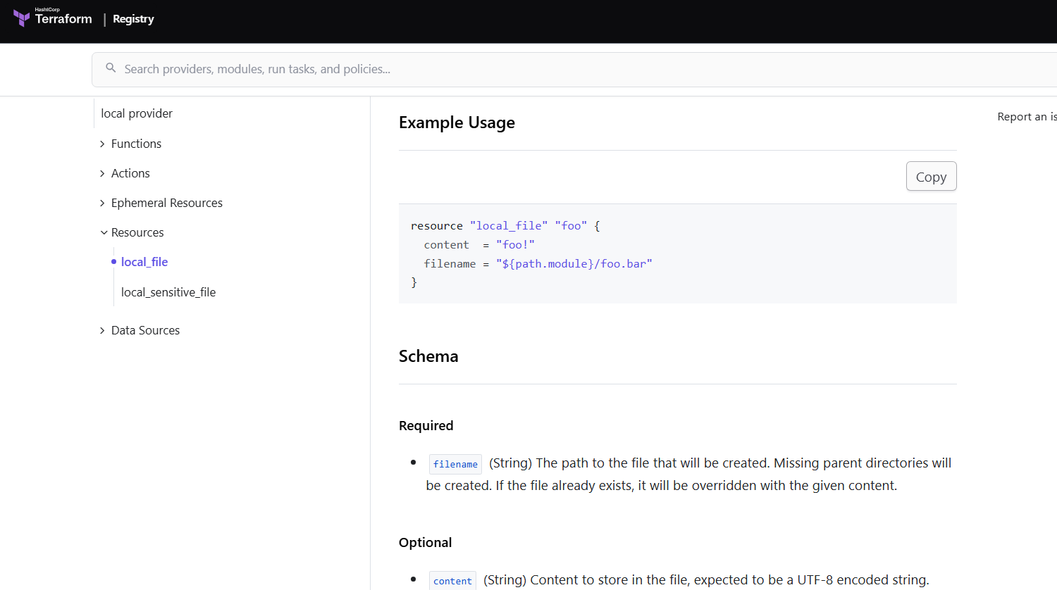
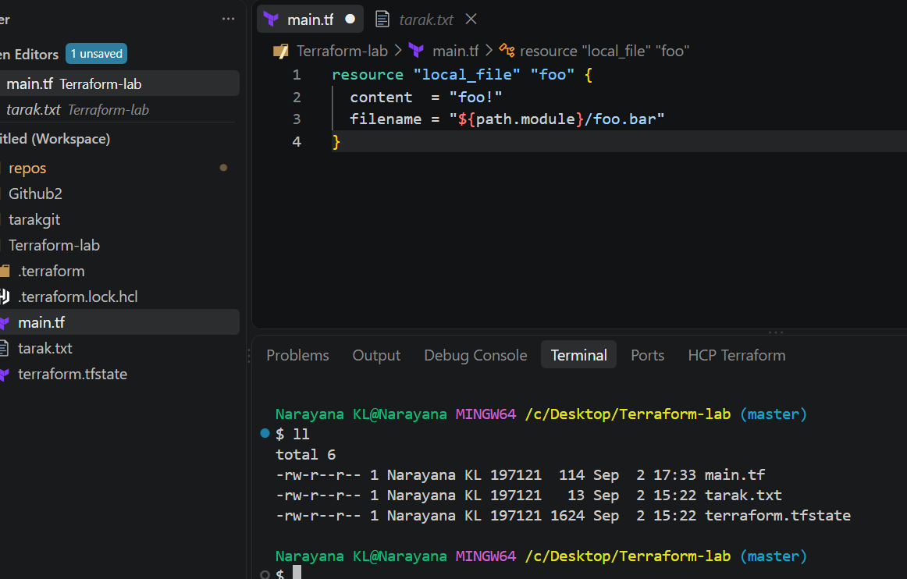
Command: $ terraform apply
Modified main.tf file
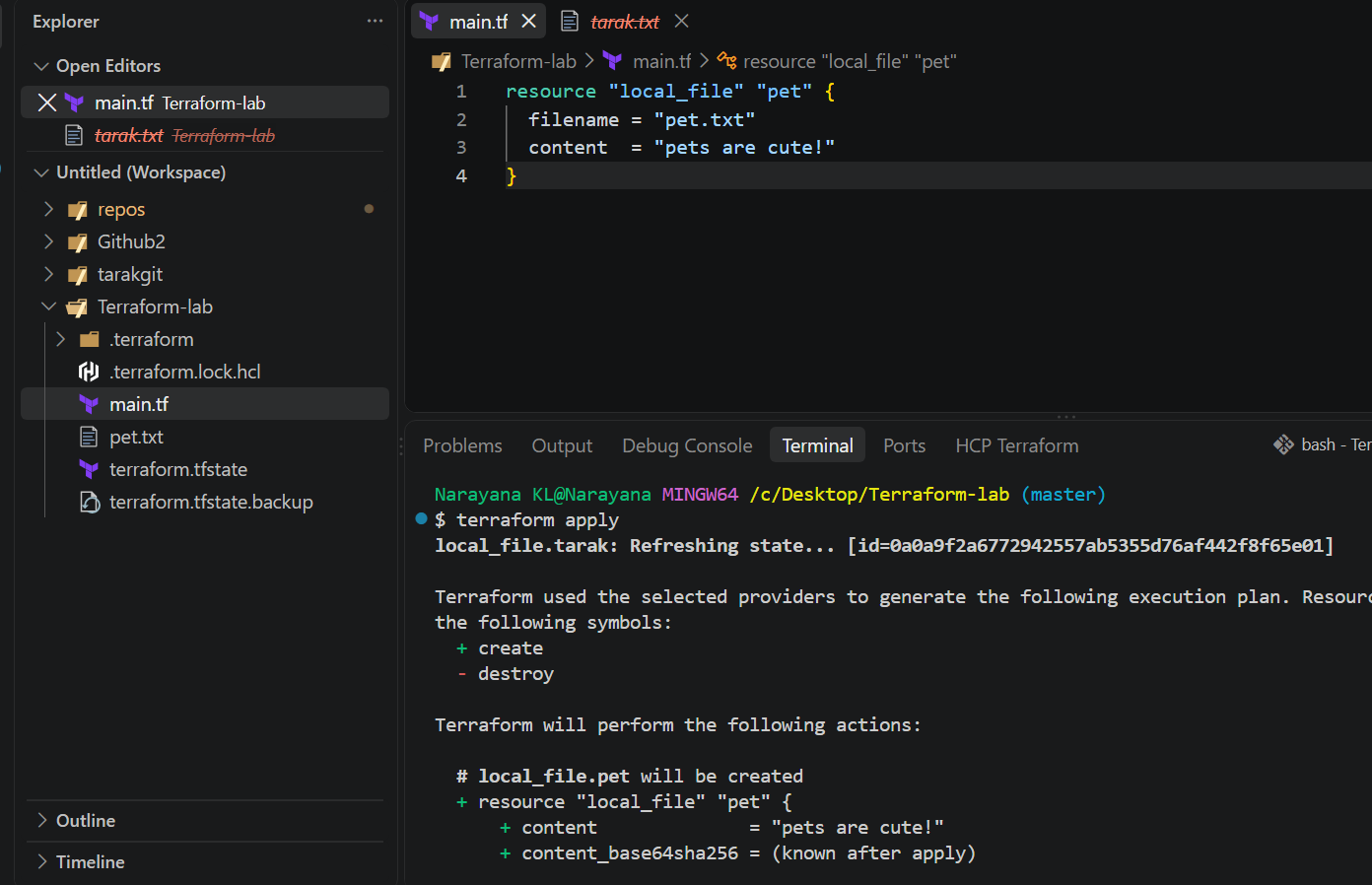
Command: $ terraform destroy
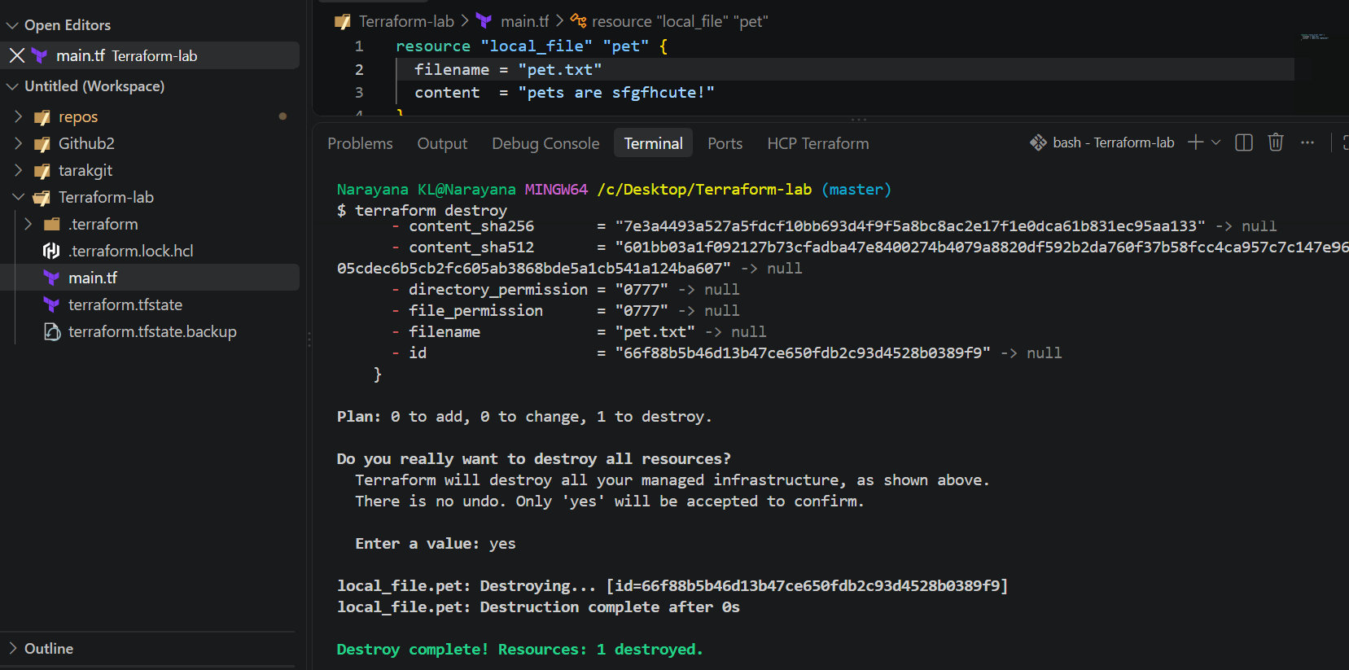
Second Template is main.tf using random provider
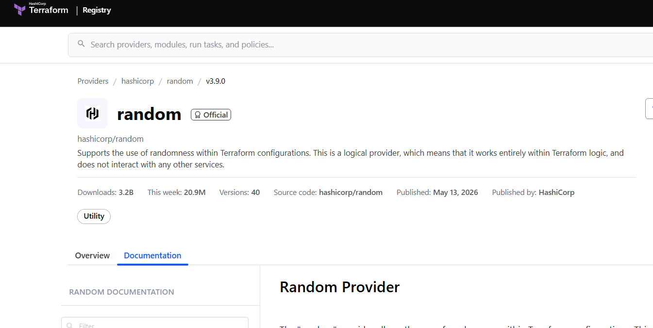
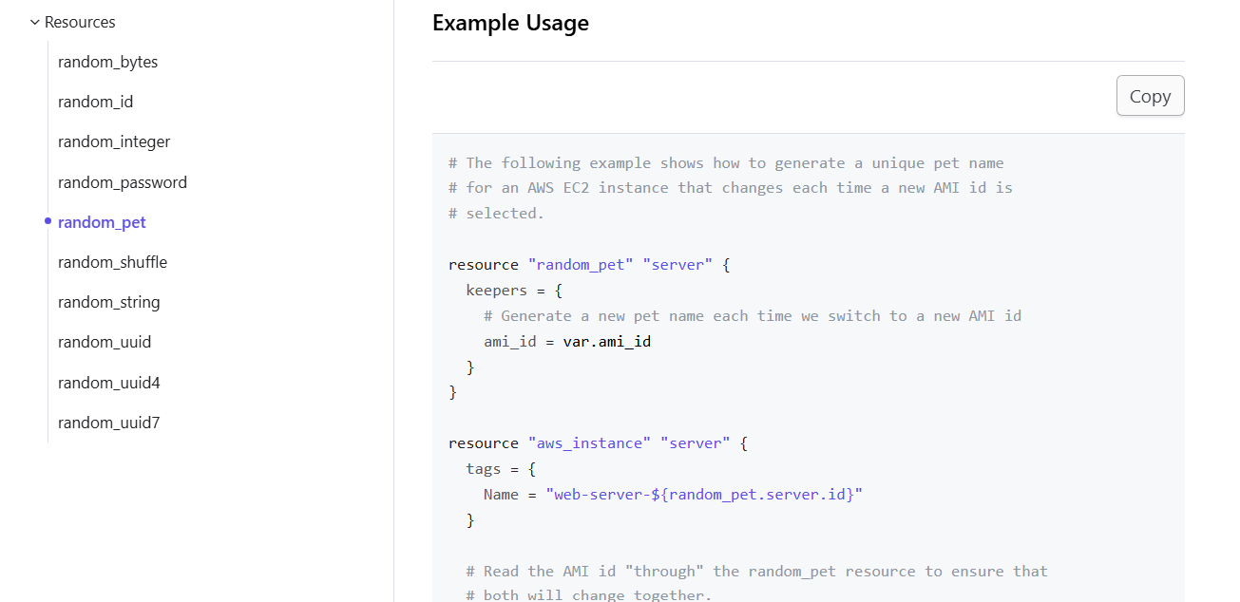
For Every provider, we need to initialise first. So, the command is “terraform init” 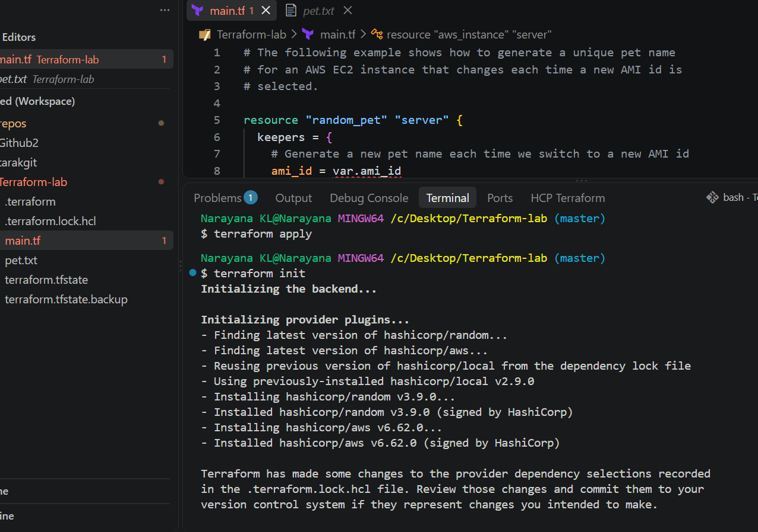
Command: $ terraformfmt $ terraform plan, $ terraform apply, $ terraform destroy
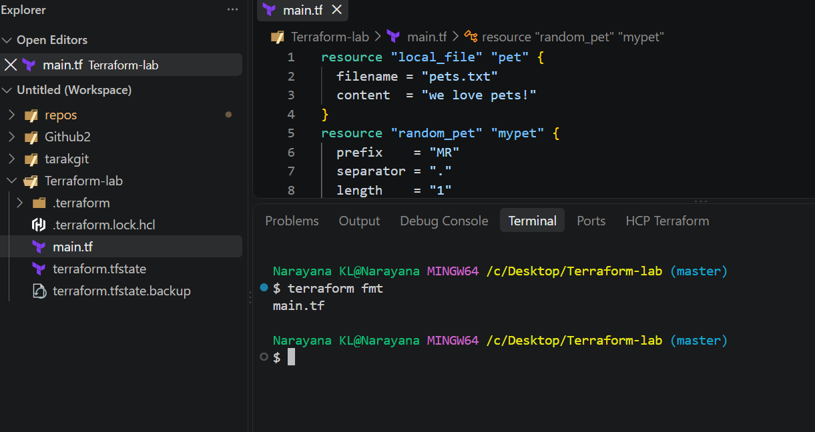
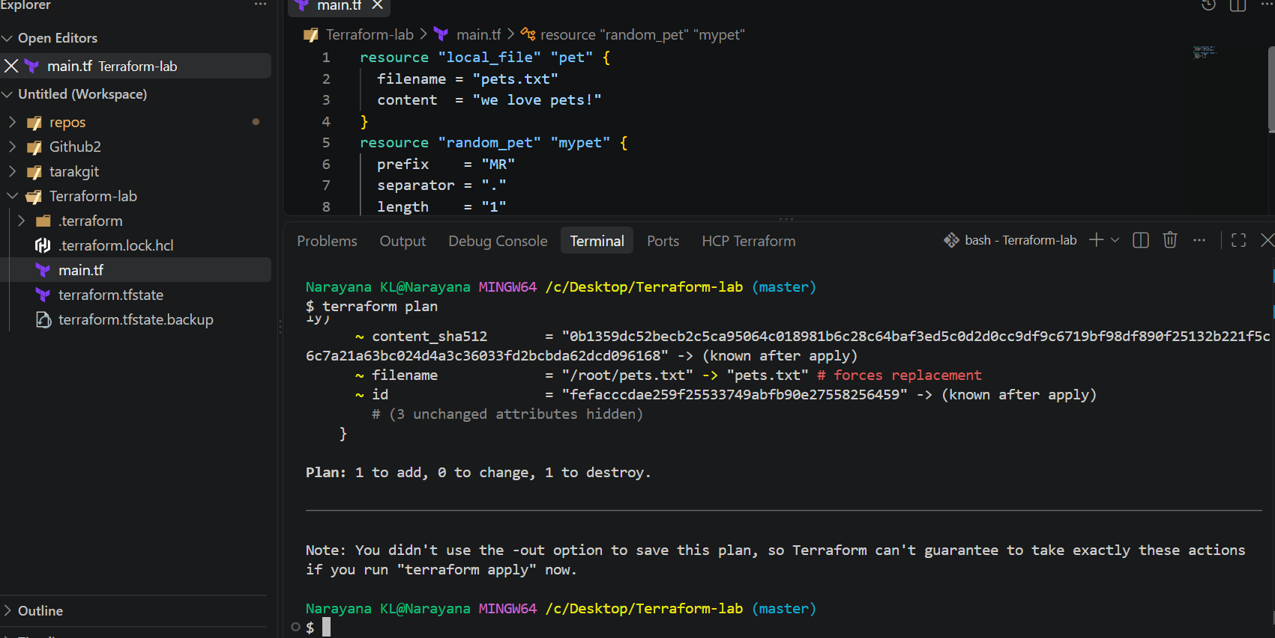
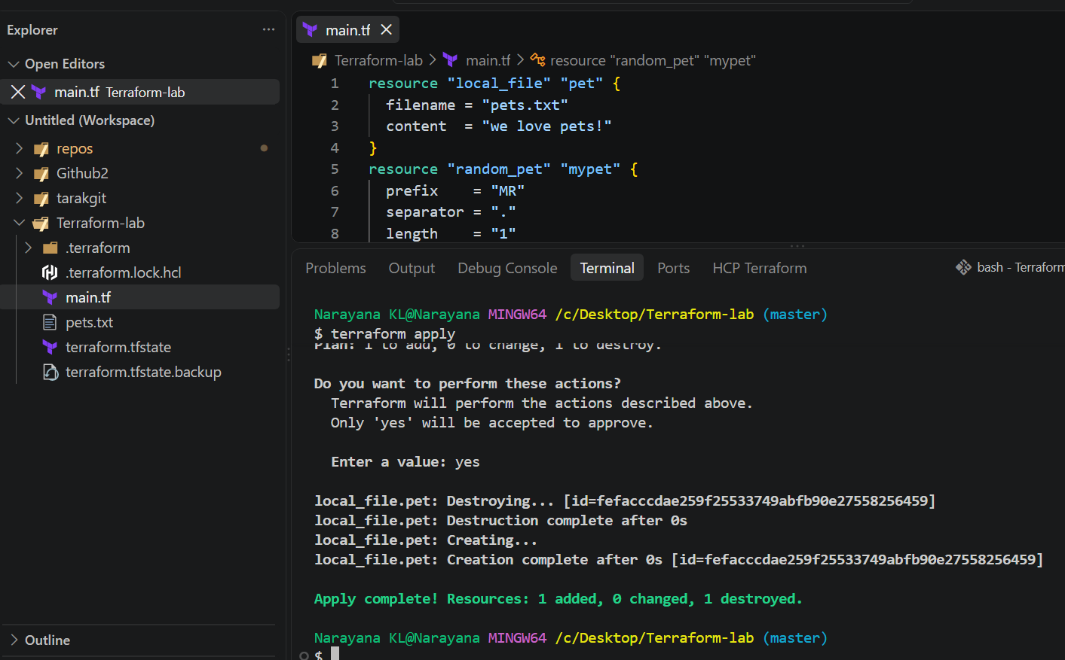
Example workflow
terraform init
terraform plan
terraform apply
Easy way to remember
init → Prepare
plan → Preview
apply → Execute
provider → Connect to cloud/services
For example, when using AWS:
provider "aws" {
region = "us-east-1"
}
Here, the AWS provider allows Terraform to communicate with AWS and manage
resources such as EC2, VPC, S3, and RDS.
Hands-on terraform Provider:
Step 1: Create a project folder
In VS Code:
File → Open Folder → New Folder
Create: terraform-provider-demo
Step 2: Create provider.tf
In the VS Code Explorer, create: provider.tf
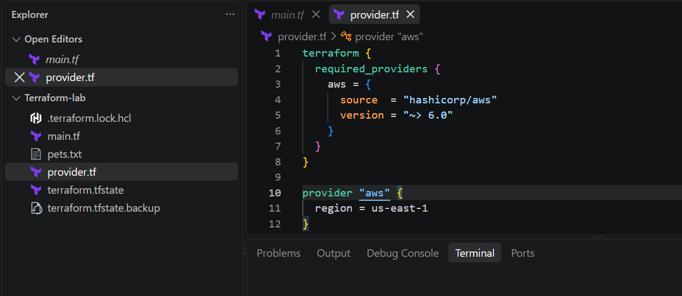
Step 3: Create main.tf
Create another file: main.tf
For a very simple provider test, we'll use the AWS caller identity data source:
data "aws_caller_identity" "current" {}
This does not create an AWS resource. It simply checks whether Terraform can
communicate with AWS using the provider.
Step 3: Open VS Code Terminal
Click:
Terminal → New Terminal
You should see something like:
C:\Users\YourName\terraform
Step 4: Initialize Terraform
Run: $ terraform init
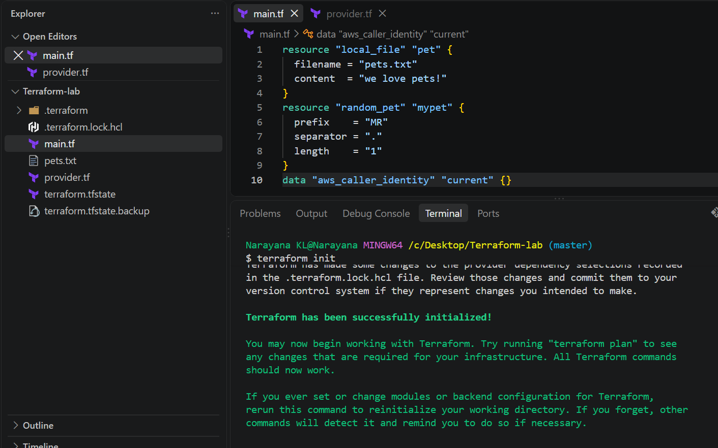
Step 5: Check the provider
Run: terraform providers
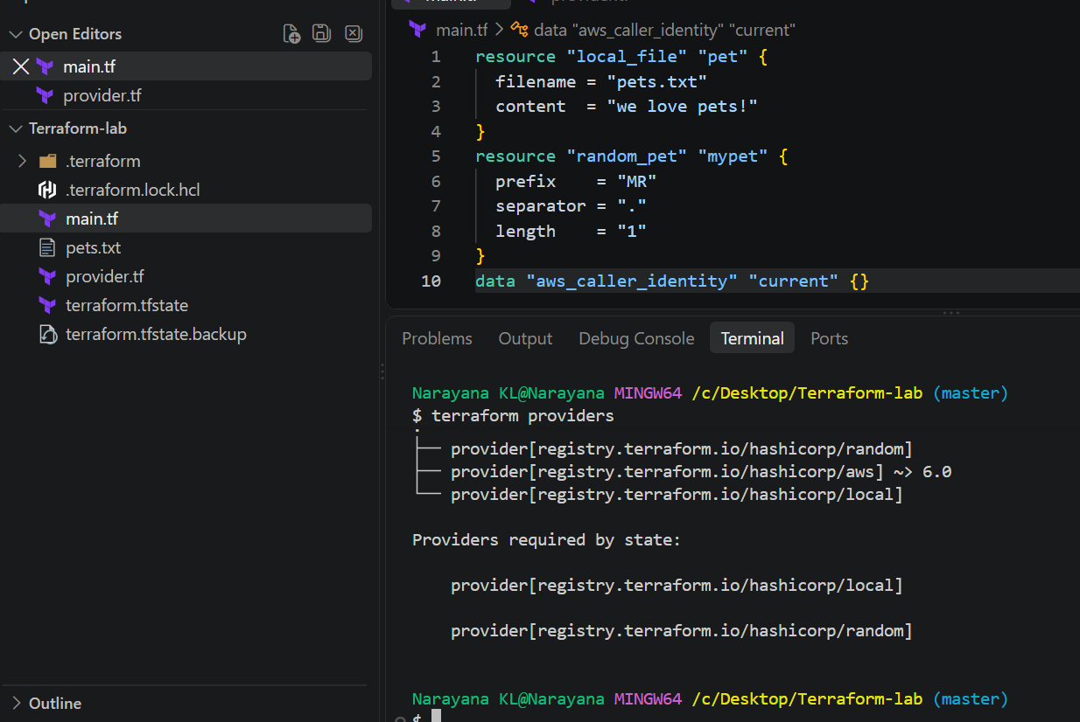
Step 7: Validate
Run: terraform validate
Expected: Success! The configuration is valid.
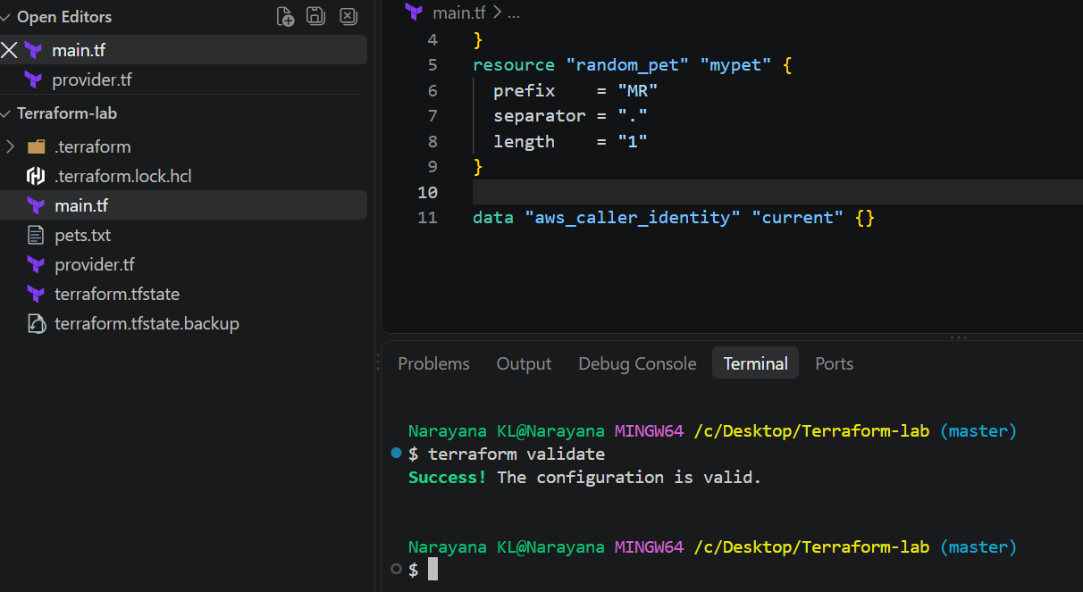
Step 8: Run Plan
Run: terraform plan
Because we're only checking AWS identity, Terraform should not plan to create an
EC2, S3 bucket, etc.
Step 9: Apply
Run: terraform apply
Type:yes

Terraform will communicate with AWS using the AWS provider. 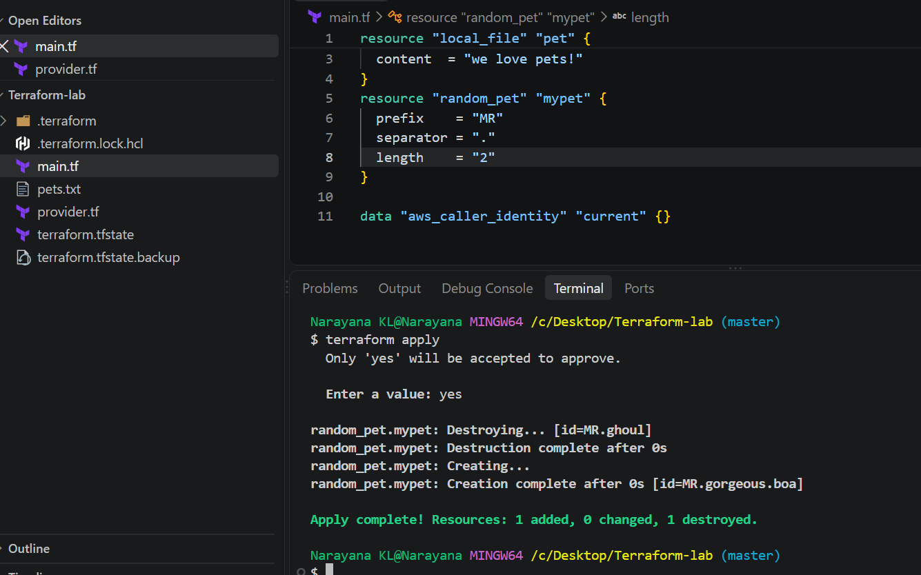
4. Integrate a sample Terraform template in Jenkins.
Objective
To integrate a Terraform configuration with Jenkins and automate Terraform execution through a Jenkins pipeline.
Step 1: Create Terraform Configuration
Create a Terraform file named:
provider.tf
Example: terraform {
required_providers {
local = {
source = "hashicorp/local"
version = "~> 2.5"
}
}
}

provider "local" {}

main.tf :
should contain below script:
resource "local_file" "sample" {
filename = "sample.txt"
content = "Terraform executed successfully through Jenkins!"
}
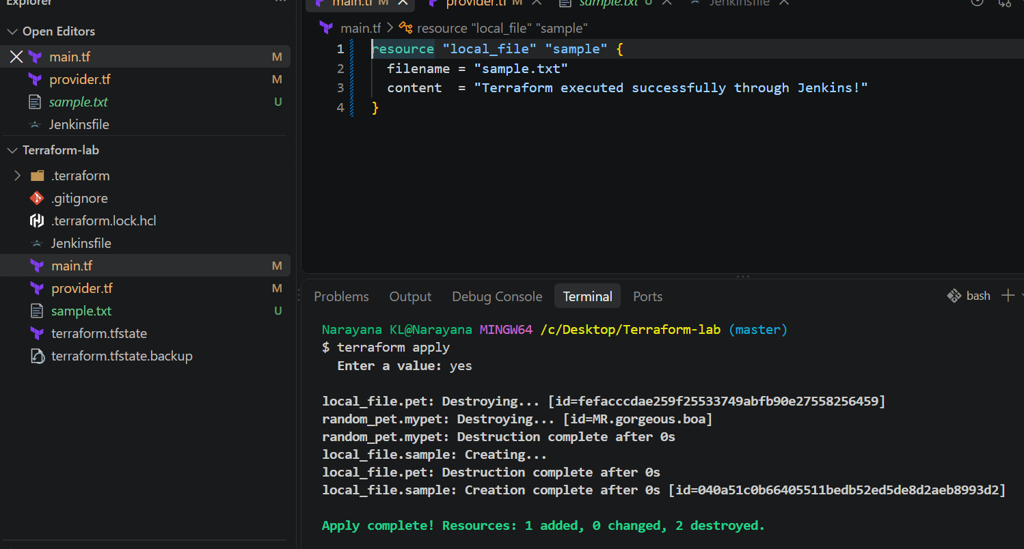
Step 2: Create Jenkinsfile
Create a file named:
Jenkinsfile
Add:
pipeline {
agent any

stages {

stage('Checkout') {
steps {
checkout scm
}
}

stage('Terraform Init') {
steps {
sh 'terraform init'
}
}

stage('Terraform Plan') {
steps {
sh 'terraform plan'
}
}

stage('Terraform Apply') {
steps {
sh 'terraform apply -auto-approve'
}
}
}
}
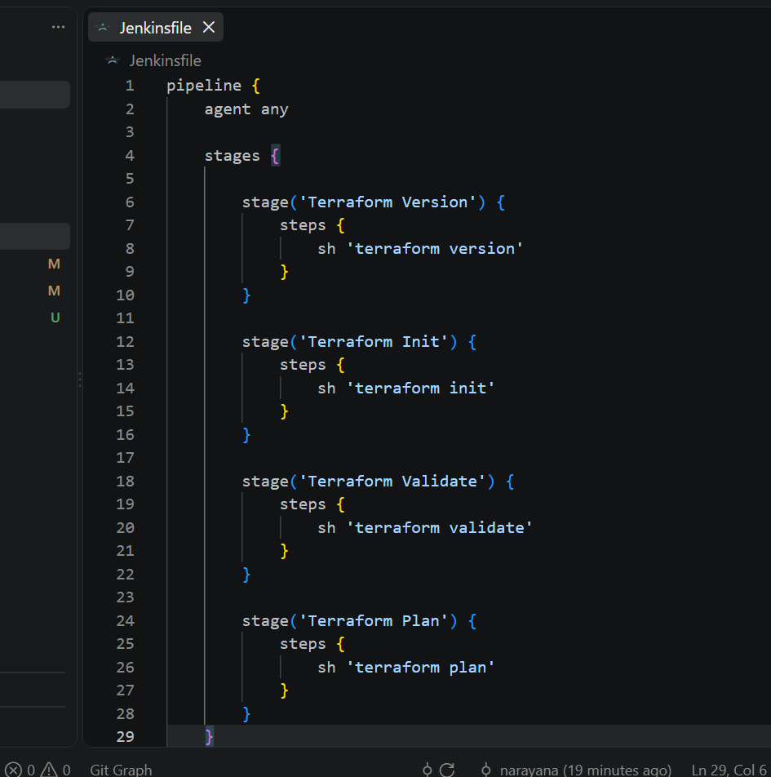
Step 3: Commit and Push the Files
From the Terraform project directory:
git add main.tf Jenkinsfile
git commit -m "Add Terraform Jenkins pipeline"
git push
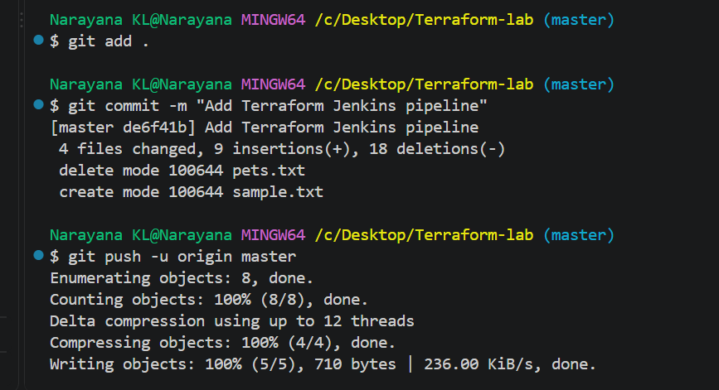
Step 4: Create Jenkins Pipeline Job
In Jenkins:
- Open Jenkins Dashboard.
- Click New Item.
- Enter a job name, for example:
Terraform-Jenkins-Pipeline
- Select Pipeline.
- Click OK.
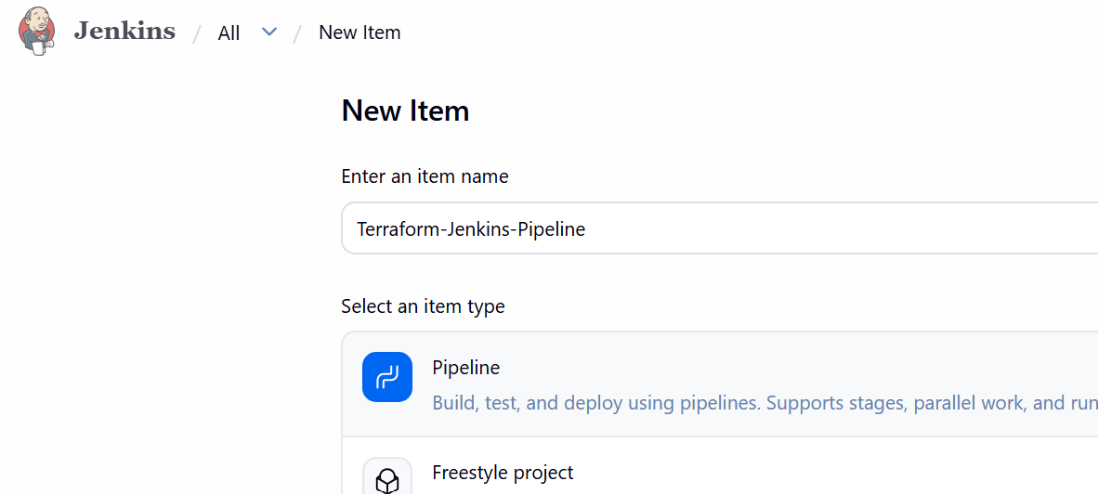
Step 5: Configure Pipeline
Under Pipeline:
- Definition: Pipeline script from SCM
- SCM: Git
- Repository URL:
https://github.com/narayana-28/Terraform-lab.git
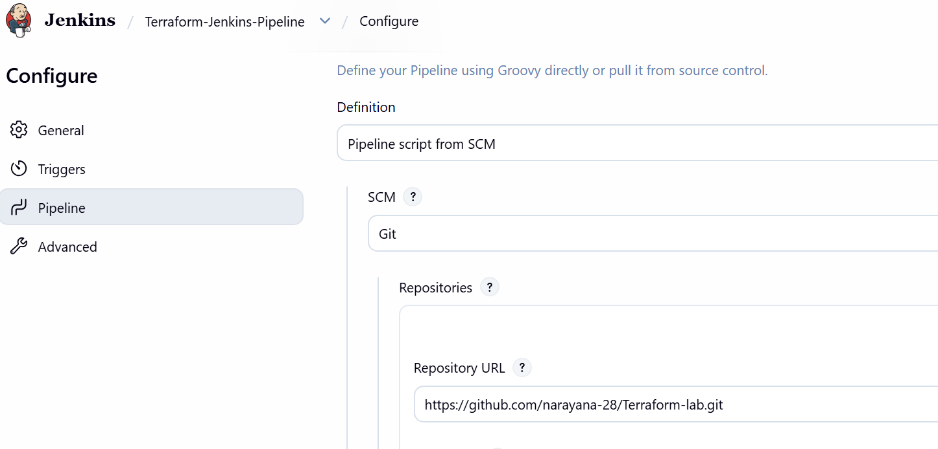
- Branch: */master
- Script Path: Jenkinsfile
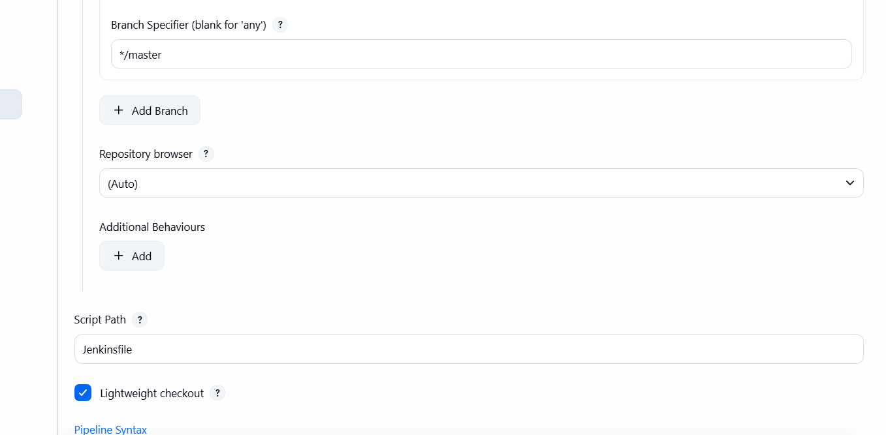
Click Save.
Step 6: Run the Jenkins Pipeline
Click: Build Now
Jenkins will execute:
Checkout
↓
Terraform Init
↓
Terraform Plan
↓
Terraform Apply
Step 7: Verify the Build
Open the Jenkins build and check Console Output.
The pipeline should complete with:
Finished: SUCCESS
